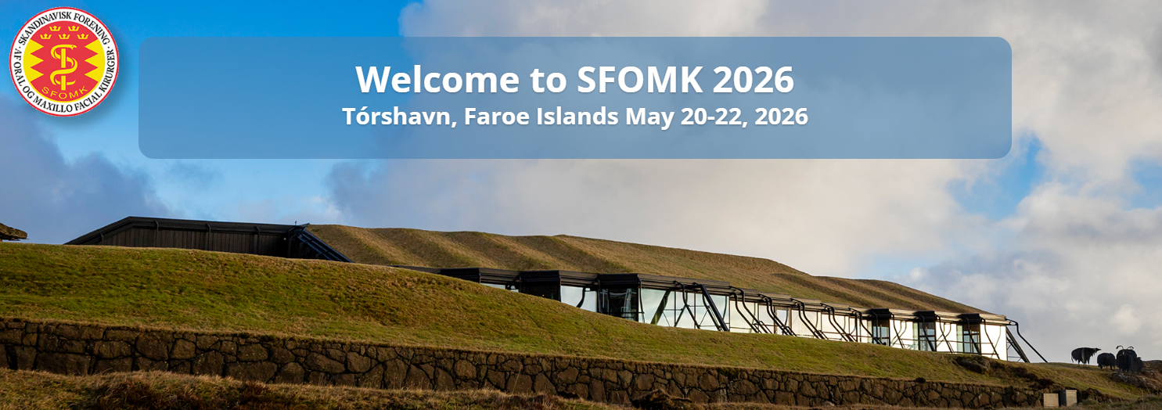
Travel form for invited speakers at 42nd SFOMK 2026, 20-22 May, Tórshavn, Faroe Islands

Information needed for your travel arrangements
First name (according to passport):
Surname (according to passport):
Mobile phone:
E-mail address:

Travelling to Tórshavn from:
Date of departure:
Desired time of departure:
Travelling from Tórshavn to:
Date of return:
Desired time of return:

Will you be checking in luggage? YES or NO
How do you wish to have your tickets sent to you? SMS or e-mail

Please send this form to congresstravel@reedmackay.com as soon as possible.

On behalf of the organizers,

Reed & Mackay
Congress secretariat for SFOMK 2026

 | E congress.se@reedmackay.com  T +46 (18) 18 35 35 (Tuesday-Thursday at 9-12)  

